Christian Kendall

5/8/2018

Dr. Gordon

CS3013

**Plate Rate**

The good and easy of the project: Visual design came quite naturally after a long sleepless drive back home from Alabama earlier in the semester, I was hit by the realization to make the app based on roads, which is fitting for a license plate rating app. I eventually sketched it on paper and then created it in Affinity Designer and made flowcharts to accompany the designs.

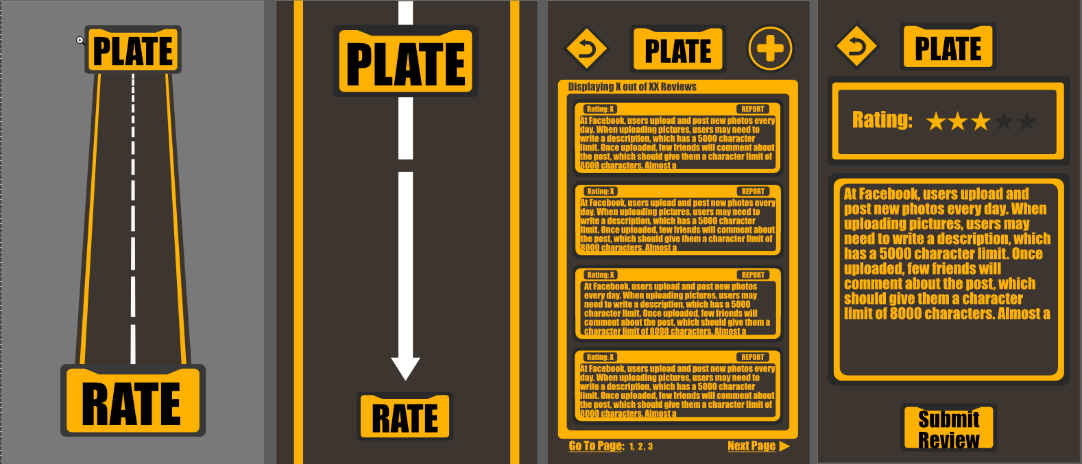

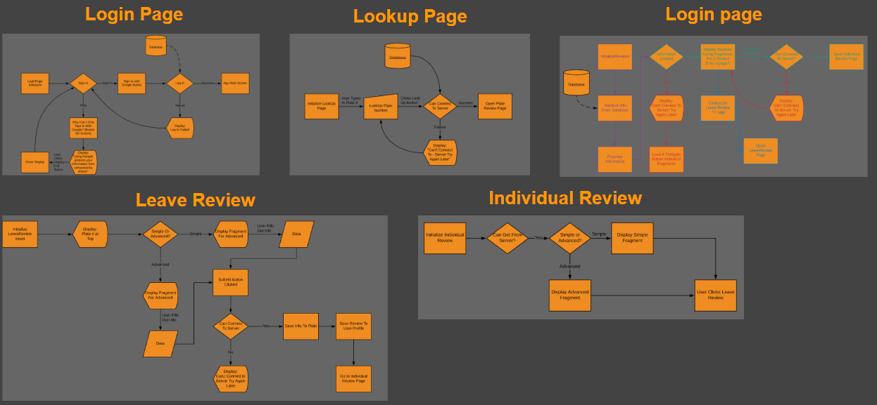

It was followed by creating a basic app with functionality:

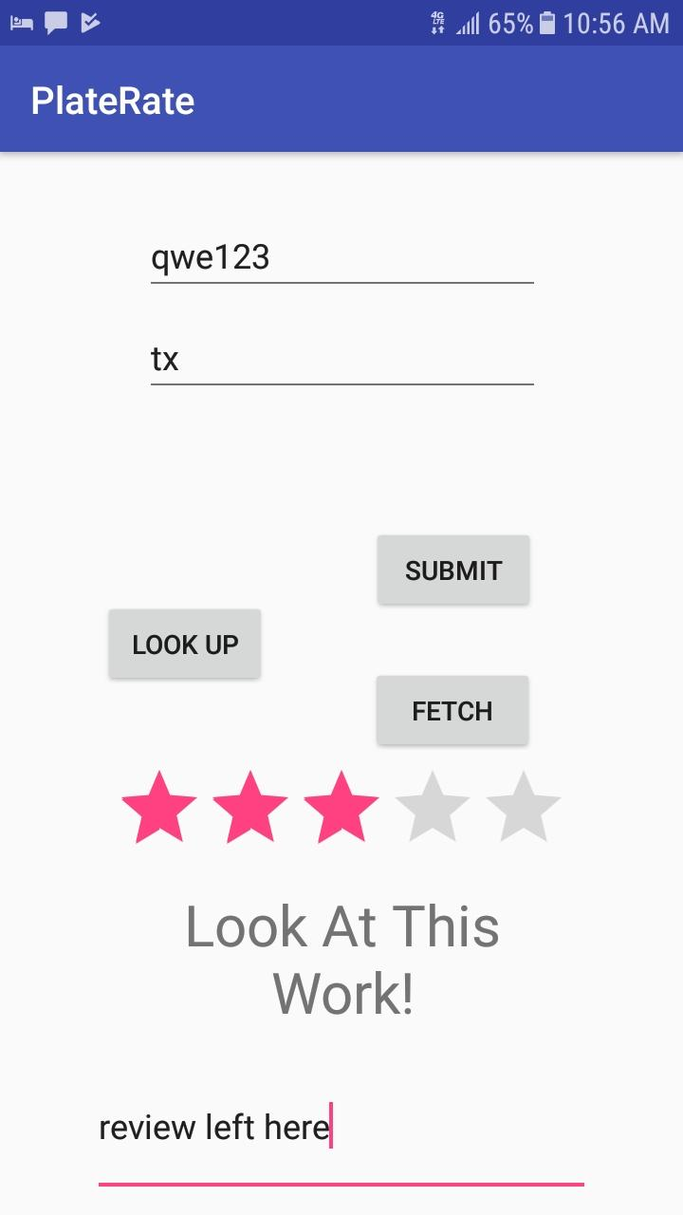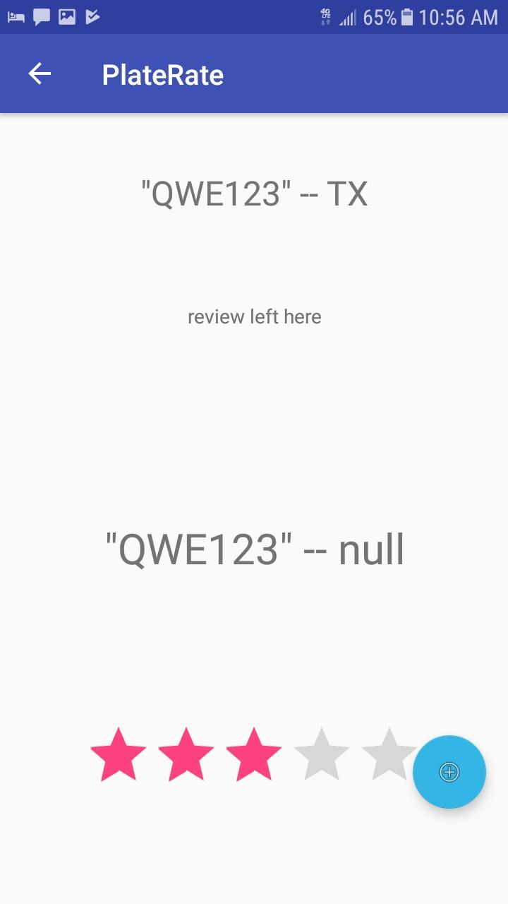

The database setup was easy going and pretty painless.



However, actually setting up the proper file layout was a pain as Cloud firestore uses documents and collections which was a new concept to me. In the current iteration there is only one review per a plate which is incorrect. Plates need to be able to hold multiple reviews. So that is a must change. But the implementation itself was fairly straight-forward. This relied on my custom ReviewData class to properly send to and receive from the server.

Passing a custom object (my review class) through intents using a serialized object also made things very easy. It allowed me to quickly pass my plate information to the next area of my app and use it accordingly (if I wanted to). It helps to streamline the experience. It is integral to my app working as it needs to as well. It also decouples and allows my code to be less cluttered which is what I am striving for. Its something I am constantly trying to improve on as I see it as a tremendous skill.

Less related to programming was an unforeseen issue. My device’s API level is right in between some deprecation of old systems and the implementation of new systems. Such as the notification system. This made it hard to develop using these systems and ultimately I decided to abandon the associated feature. (Notification that review was saved or not)

My final project had various hardships associated with it. Many were technical and design flaws with the creation of the app itself. However, I ran into a larger issue which I should have known better than to get involved with. This issue was feature creep.

I repeated found myself trying to implement a spectrum of features before completing the foundation of the app. This caused me to encounter setback after setback. Which inevitably has lead me to an incomplete and visually displeasing final project. With that being said, it was a fantastic learning experience. I understand now that I should scope back ideas and implement the main experience first and then move onto less pressing features. Will I make this mistake again? Probably, but hopefully on a smaller scale.

However, I really enjoy working on mobile applications. It's a nice change from traditional or video game development. It feels a lot smaller on scale but at the same time more impactful. The changes can be seen quickly and the ease of use is tremendous. With the growing rate of mobile use, this is definitely a field I would like to pursue further along with finishing this particular app in the coming weeks.

I would like to further my knowledge on it and going into more of the features such as Adapters. It appears we have just scratched the surface and the deeper I look, the better designs and usability the apps I create will be.

Final note, I had to remove the GPS location. To include a sensor I put in a tone and vibration for failure of adding a review and on success as well.